DBMS Project
Supermarket

Team E

Arpit Singh (111601031)
Pankaj Kumar (111601014)
Sparsh Jain (111601026)

Contribution:
1. Arpit Singh: Database Design including ERD designing and Schema Development, Remove constraints to maintain atomicity while keeping the integrity of the database constant, decide roles, create views for ease of access, design triggers, fine tuning the front end for specific roles

2. Sparsh Jain: State basic requirements of the database to start the design, Schema Development, grant privileges required to for each role (including dependencies due to triggers), write functions/procedures for ease of use, pushing towards aesthetic values of the front end

3. Pankaj Kumar: Proof checking of requirements and ERD, Insert Values to visualise the effects of database, BCNF checking, major front end development involving creation of various pages in visually appealing format

Requirements:
Who are the users of this system?
- Admin
- Managers
- Cashiers
- Non-Login Users (Customers, Other Employees)
Roles:
- Admin: Can Access and Modify all entries of the database.
- Managers: Can Hire/Fire Employees of his own department, Update vacancies in his department, Update Employee details of his department, Can add/remove/modify/order a product from its suppliers, and update the supply table when product is supplied. Can create a new discount or modify an existing one. Has read access to all the tables and Modify access to only tables required to do the above tasks for his own department only.
- Cashiers: Can create a new bill, add/remove items from a bill, may apply discount if applicable, has read access to products, discounts, and customer details. Can also add/modify the details of a customer. On customer request, he can also produce details of a bill.
- Non-Login Users can check details of a product and applicable discounts.
Update the stock of the product automatically when an order is supplied.
The order can be fulfilled through multiple supplies, and multiple orders can be fulfilled through a single supply.
Update the stock of the product automatically when it is added/removed from a bill.
An interface for the admin and managers (for his own department) to perform few important combination of queries such as profit/loss in a given time period, etc.
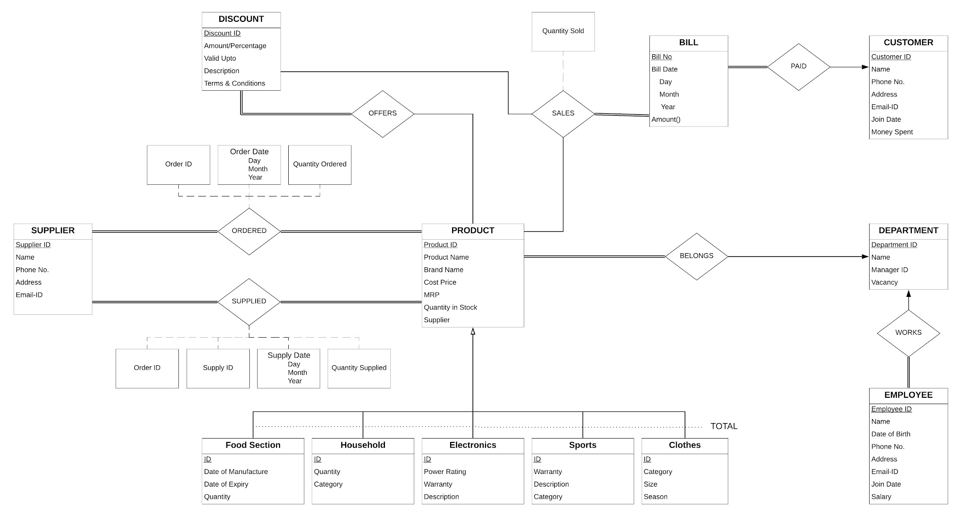

View details
- Create views for employees of different department to see the details of products of their respective departments (5 x {department}Details) = 5 views
- Create view for customer to see relevant details of products of all departments (5 x view{department} + 1 viewProduct) = 6 views
- Create a view viewDiscount to see all valid discounts applicable across products
- Create views for manager to update product/employee details in their own departments (5 x [product/employee]{department} + employeeCashier) = 11 views
Total - 23 views

Roles
- Admin role (all privileges)
- Individual managers of 5 product department + cashier
- Customer
- Cashier
- Employees of each department

Privileges
- All privileges to admin with grant option

- Select on bill to all managers
- Select on customer to all managers
- All privileges on discount to all managers
- All privileges on offers to all managers
- Select on product to all managers
- All privileges on ordered to all managers
- Select on department to all managers
- Update only vacancy in department to all managers
- Select on sales to all managers
- All privileges on supplier to all managers
- All privileges on supplied to all managers

- All privileges of Cashier to Cash Manager with admin option
- All privileges on employeeCashier to Cash Manager

- All privileges of foodEmployee to foodManager with admin option
- All privileges on foodSection to foodManager
- All privileges on productFood to foodManager
- All privileges on employeeFood to foodManager

- All privileges of householdEmployee to householdManager with admin option
- All privileges on householdSection to householdManager
- All privileges on productHousehold to householdManager
- All privileges on employeeHousehold to householdManager

- All privileges of sportsEmployee to sportsManager with admin option
- All privileges on sportsSection to sportsManager
- All privileges on productSports to sportsManager
- All privileges on employeeSports to sportsManager

- All privileges of electronicsEmployee to electronicsManager with admin option
- All privileges on electronicsSection to electronicsManager
- All privileges on productElectronics to electronicsManager
- All privileges on employeeElectronics to electronicsManager

- All privileges of clothesEmployee to clothesManager with admin option
- All privileges on clothesSection to clothesManager
- All privileges on productClothes to clothesManager
- All privileges on employeeClothes to clothesManager

- All privileges of customer to all employees
- Select on discount to all employees
- Select on offers to all employees

- Select on foodDetails to foodEmployee
- Select on householdDetails to householdEmployee
- Select on sportsDetails to sportsEmployee
- Select on electronicsDetails to electronicsEmployee
- Select on clothesDetails to clothesEmployee

- All privileges of customer to cashier with admin option
- Select on product to cashier
- Update only quantity in stock on product to cashier
- Select on discount to cashier
- Select on offers to cashier
- Select on viewDiscounts to cashier
- All privileges on sales to cashier
- Select on bill to cashier
- Insert on bill to cashier
- Update only amount on bill to cashier
- Select on customer to cashier
- Insert on customer to cashier
- Update on customer to cashier

- Select on viewFood to customer
- Select on viewHousehold to customer
- Select on viewSports to customer
- Select on viewElectronics to customer
- Select on viewClothes to customer
- Select on viewProducts to customer
- Select on viewDiscounts to customer

Triggers
- Managers can ‘receive’ products for their own departments only
- Managers can add new products for their own department only
- Managers can offer a discount for their own department only
- Managers can order products of their own department only
- Managers can update vacancy of employees of their own department only
- Managers can update supply of products of their own department only

- Prevent fraudulent supply, ie do not allow supply of a product more than ordered
- Automatically increment quantity in stock of products when a product is received
- Prevent fraud transactions, ie do now allow customer to buy more products than in stock
- Automatically decrement quanitity in stock of products when a product is sold
- Detect whether the discount applied is available or expired
- Automatically update the billing amount as the items are sold
- Automatically update the total amount spent by the customer with billing amount

Graphical Interface (Before)
- Show Product Table
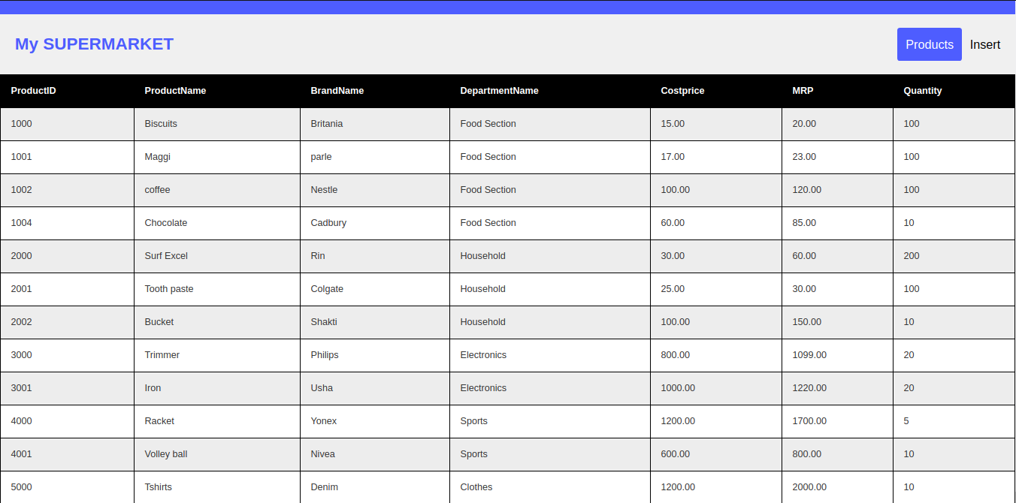

- Show Discount Table
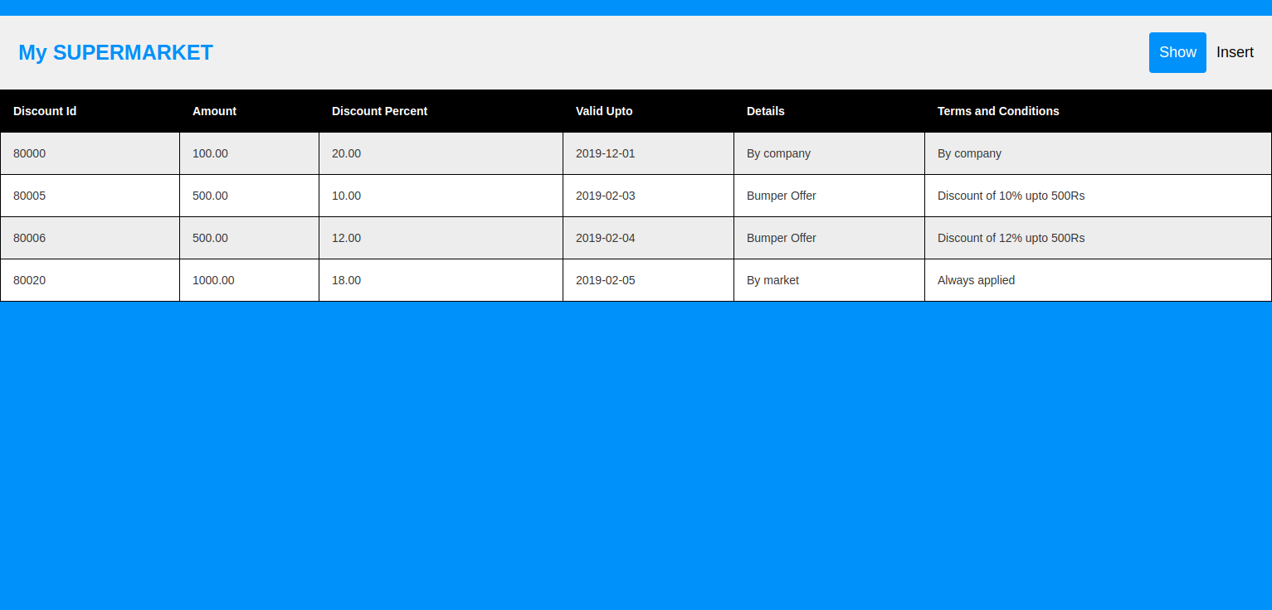

- Insert in Product Table
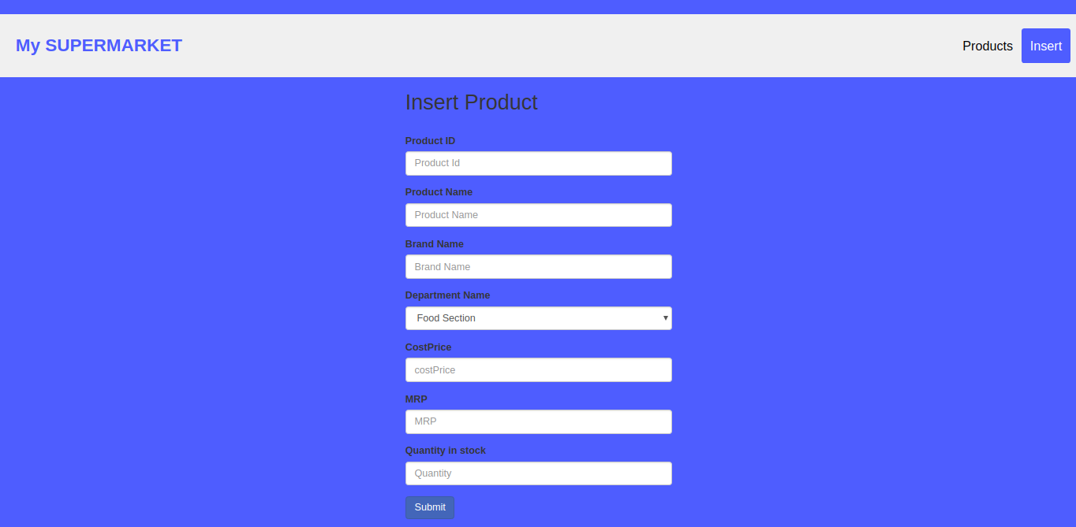

- Insert in Food Section Table
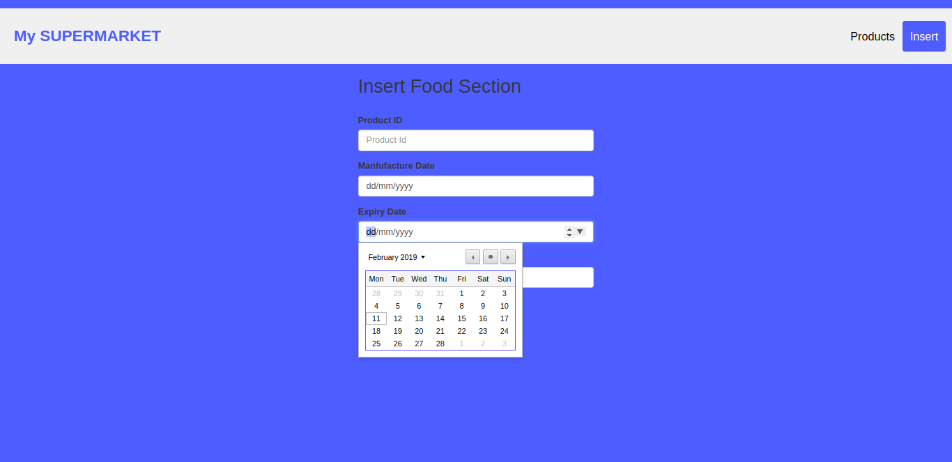

Use Cases
- Show all Available discounts
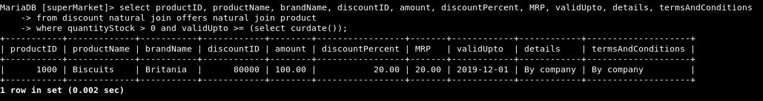

- Show food product details to customer
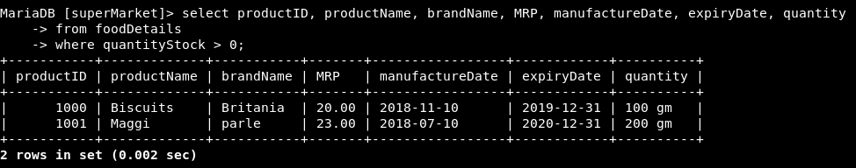

- Show orders and supply to check unfulfilled orders
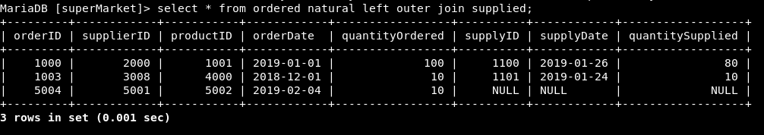

BCNF Checking
- product (productID, productName, brandName, departmentName, costPrice, MRP, quantityStock)
Dependencies:
- productID -> product (productID is primary key, hence superkey)
- (productName, brandName) -> departmentName ((productName, brandName) is a superkey)

- foodSection (productID, manufactureDate, expiryDate, quantity)
Dependencies:
- productID -> foodSection (productID is primary key)

- household (productID, quantity, category)
Dependencies:
- productID -> household (productID is primary key)

- electronics (productID, powerRating, warranty, details)
Dependencies:
- productID -> electronics (productID is primary key)

- sports (productID, warranty, details, category)
Dependencies:
- productID -> sports (productID is primary key)

- clothes (productID, category, size, season)
Dependencies:
- productID -> clothes (productID is primary key)

- department (departmentName, managerID, vacancy)
Dependencies:
- departmentName -> department (departmentName is primary key)

- employee (employeeID, employeeName, DOB, phoneNo, employeeAddress, emailID, joinDate, salary, departmentName)
Dependencies:
- employeeID -> employee (employeeID is primary key)

- supplier (supplierID, supplierName, phoneNo, supplierAddress, emailID)
Dependencies:
- supplierID -> supplier (supplierID is primary key)

- ordered (orderID, supplierID, productID, orderDate, quantityOrdered)
Dependencies:
- orderID -> ordered (orderID is primary key)

- supplied (supplyID, orderID, supplyDate, quantitySupplied)
Dependencies:
- supplyID -> supplied (supplyID is primary key)

- discount (discountID, amount, discountPercent, validUpto, details, termsAndConditions)
Dependencies:
- discountID -> discount (discountID is primary key)

- offers (discountID, productID)
Dependencies:
- (discountID, productID) -> offers (trivial)

- customer (customerID, customerName, phoneNo, customerAddress, emailID, joinDate, moneySpent)
Dependencies:
- customerID -> customer (customerID is primary key)
- (customerName, phoneNo) -> customer ((customerName, phoneNo) is super key)

- bill (billNo, billDate, customerID, amount)
Dependencies:
- billNo -> bill (billNo is primary key)

- sales (billNo, productID, discountID, quantitySold)
Dependencies:
- (billNo, productID) -> sales ((billNo, productID) is primary key)

Hence All Tables are in Boyce-Codd Normal Form!

Functions and Procedures
- Find current monthly profit per department: Takes input a department name and month & year, and gives corresponding profit of the department (profit is less due to various discounts applied on different products, some discounts are percent based, while others are value based)
- Find critical products: Takes input a department name, and critical quantity, if quantity is stock is less than critical quantity, then order should be placed. Helps managers to decide which order should be placed
- Customer of the Month: A customer each month will be given a gift voucher who spent the maximum in the market as an appreciation. Find details of that customer for any month easily with this procedure.
- Best Customer: Customer who has all time high record of spenditure in the market is given yet another token of appreciation.
- UnfulfilledOrders: Find which orders are still pending with the number of days passed to help managers differenciate between good and bad suppliers
- GetDiscounts: Enter a product ID and get all the currently applicable discounts at the time of buying a product to get the best value of your money. A greate advertisement to showcase our market as better than other people’s ;)

Front End!
We have included some basic yet powerful features in our front end. Unfortunately, we could not create a full fledged graphical interface, but the main pages allowing complete access to the admin are implemented. A portion of the cashier’s interface is also created for comfortable billing. Following are some screenshots attached along with the description of features available there.

1. The Login Page
The starting of any secure system starts with a secure logging method. MariaDB already provides us the facility of having user and password tables, implementing it in the GUI is another task though.

2. The Products Page
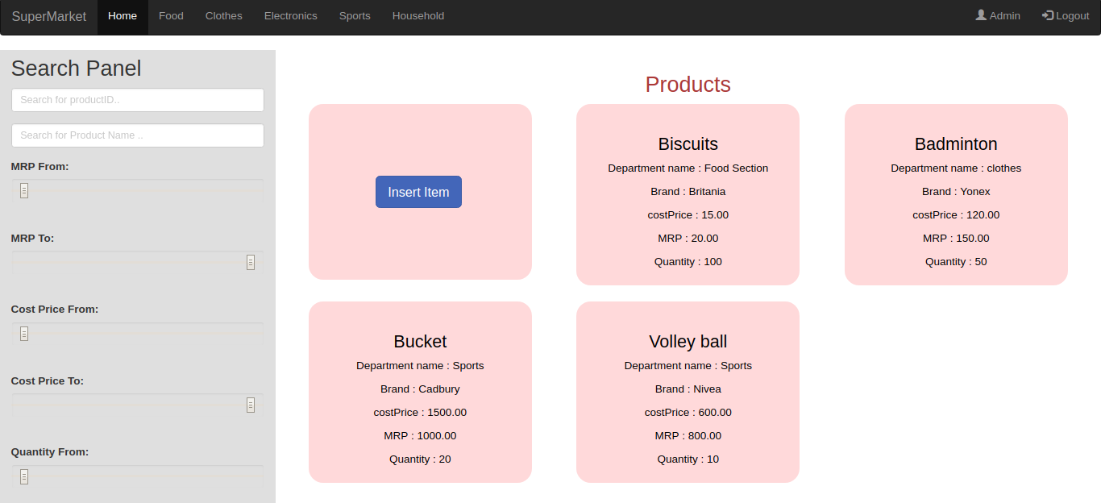
A sample page which includes scrollable cards to show all the details about the products neatly, also including a link to insert a new item in the products table. Left hand side, a search panel can be seen where customised search querries on the product can be made based on productID, product name, min/max MRP or cost price, quanitity available in the stock, etc etc. On the top we have implemented links to other such pages for quick navigation.

3.The Insert Item Page
When you click the link in the previous page to insert a new product, a pop up window shows asking about the product details. Radio buttons allow to choose the departments from only the available ones hence fulfilling the foreign key constraint. As soon as you select one of the departments, other department dependent details of the product appear below that as it can be seen in the screenshot below. These details go in separate tables automatically based of the department chosen so that the user does not have to worry about scrolling through the right pages to insert a product in the table.
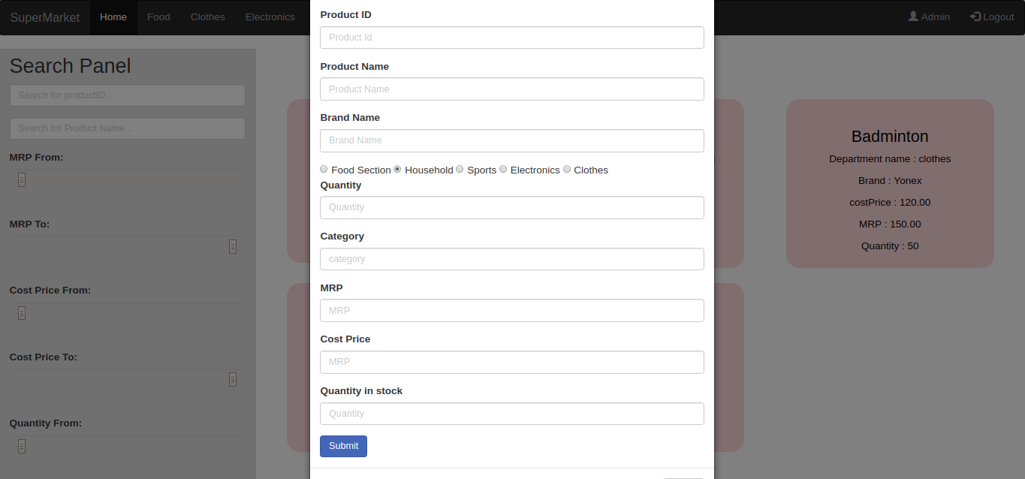
4. The Supplier Details
Another example of a page showing details of the supplier, it is similar to the products page, but showcases a different table on the interface.
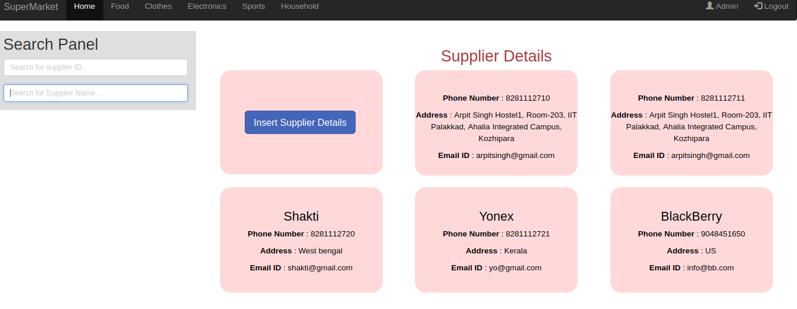

5. The Billing Page
The billing page for the cashier is now made even more friendly with cards showing details like MRP, brand, and quantity left. Billing through this page is as easy as clicking the ‘add’ buttons on the corresponding products cards and then checking out to generate an automated summary of the bill.
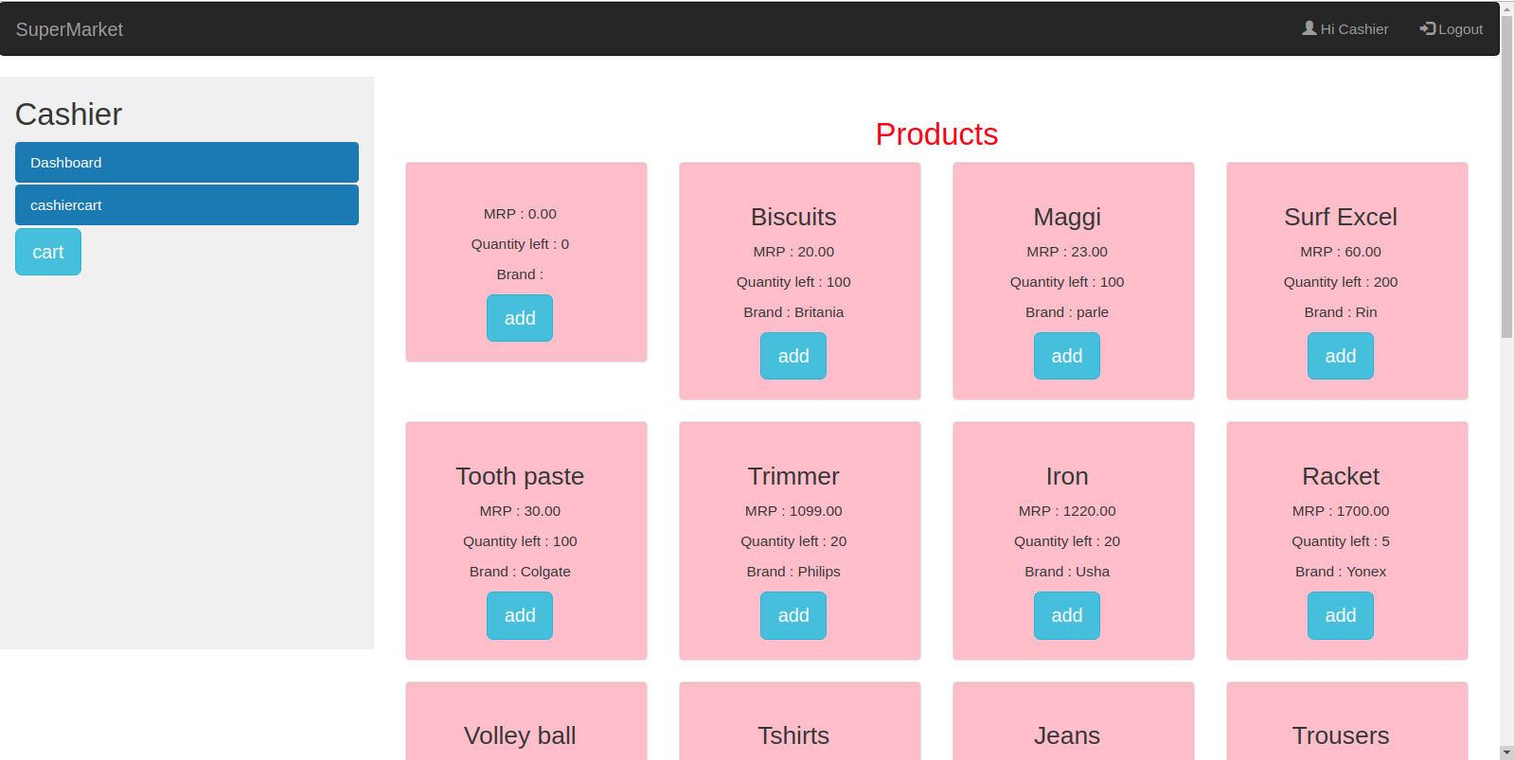

INDEXING
Most of the querries in our database are done on the products based on their productID. Whether it be searching for relevant discounts, or quanitity remaining, adding for the bill, or receiving a shipment, products are marked with the productID everywhere. Hence it makes sense to place indexing on the productID for faster accessing. We have added indexing on the productID field for the very reason. However, other tables and fields are not so frequently accessed and hence indexing or hashing is not required as such.

